**SHAHEED UDHAM SINGH COLLEGE OF ENGINEERING &TECHNOLOGY, TANGORI (MOHALI)**

***Department of Computer Science & Engineering***



**PROJECT-FILE**

**(BTCS-703)**

**7th Sem.**

**Submitted To: Submitted By:**

**Er. Deepinder Kaur Name = Paras**

**(HOD) Rollno.(1712186)**

**Table of Contents**

**TOPIC PAGE NO.**

1. **About the project (Food ordering receipt System)**

### 1.1. Define your objectives. 1

### 1.2. Define the functionality. 2

### 1.3. Make a budget. 2

### 1.4. Look for a software or app development company. 3

### 1.5. Start developing the online ordering platform. 3

1. **PYTHON INTRODUCTION** 
   1. Why Python? 4
   2. Uses of Python. 5-6
2. **DETAILS ABOUT PROJECT**

3.1 introduction of project 7-10

1. **REQUIREMENTS** 
   1. Hardware Requirement 11-12

4.2 Software Requirement 13-16

1. **CONCLUSION** 17
2. **REFERENCES** 18

**CHAPTER 1**

**About the project (Food ordering receipt System)**

### **Define your objectives**

Developing a platform for your business is important. It is more important to build it for the right reasons. You need to identify your objectives behind developing the ordering system. We have prepared some questions that will help define the objectives clearly.

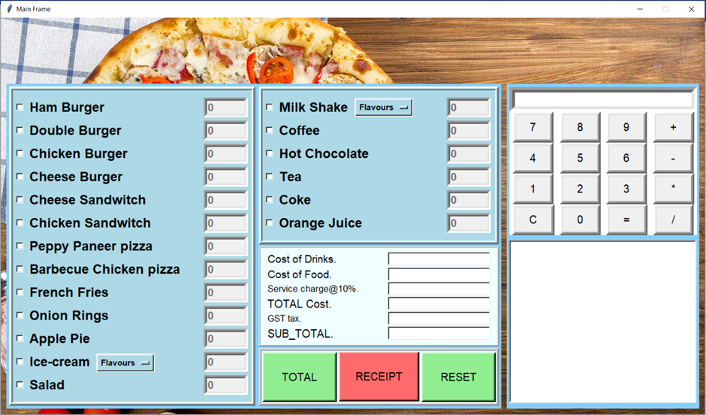

* + Do you need to solve a problem by building this ordering system? What is that problem?
  + Which section of your business needs improvement?
  + How do you plan to reach more customers?
  + Do you want to make the ordering process convenient for the customers and you?
  + Do you want to create awareness for your brand?

### **Define the functionality**

After deciding your objectives, the next step is to define the functionality of the system. But, how will you identify the required functionality?

* + First, jot down all your requirements and functionalities.
  + Study your competitors and see if you need a similar platform.
  + Think about additional functionalities that will give your solution an edge over others

### **Make a budget**

The third step is to create an appropriate budget for your restaurant online ordering software. You need to keep a few things in mind:

* + Do not be very rigid with your budget. Make sure you have some room to make adjustments if you need additional functionality in your mobile ordering system.
  + Do not allocate too much money for the project if you can get the essential functionality in less budget.

### **Look for a software or app development company**

While looking for developers for your online ordering system project, you should choose a company that has experience in developing similar food ordering platforms.

This experience will help in the development of your project as the developer will have the required knowledge to develop the functionality as well as will know how to handle any issues that arise during the process.

### **Start developing the online ordering platform**

After you hire the developers, you can get an NDA signed for the safety of the app idea. Now you can discuss your idea with developers and start working on the online ordering system.

**CHAPTER 2**

**PYTHON INTRODUCTION**

**2.1 Why Python?**

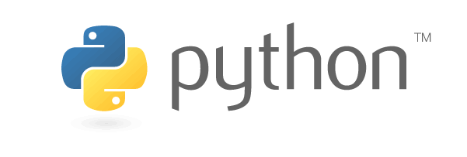

Python, designed by Guido van Rossum in 1991, is a widely used high-level, general-purpose, interpreted, dynamic programming language. Its design philosophy emphasises code readability, and its syntax allows programmers to express concepts in fewer lines of code than possible in languages such as C++ or Java. The language provides constructs intended to enable clear programs on both a small and large scale.

Python supports multiple programming paradigms, including object-oriented, imperative and functional programming or procedural styles. It features a dynamic type system and automatic memory management and has a large and comprehensive standard library.

Python interpreters are available for many operating systems, allowing Python code to run on a wide variety of systems. Using third-party tools, such as Py2exe or Py installer, Python code can be packaged into stand-alone executable programs for some of the most popular operating systems, so Python-based software can be distributed to, and used on, those environments with no need to install a Python interpreter.

**2.2 Why we should use python?**

**1) Readable and Maintainable Code**

While writing a software application, you must focus on the quality of its source code to simplify maintenance and updates. The syntax rules of Python allow you to express concepts without writing additional code. At the same time, Python, unlike other programming languages, emphasizes on code readability, and allows you to use English keywords instead of punctuations. Hence, you can use Python to build custom applications without writing additional code. The readable and clean code base will help you to maintain and update the software without putting extra time and effort.

**2) Multiple Programming Paradigms**

Like other modern programming languages, Python also supports several programming paradigms. It supports object oriented and structured programming fully. Also, its language features support various concepts in functional and aspect-oriented programming. At the same time, Python also features a dynamic type system and automatic memory management. The programming paradigms and language features help you to use Python for developing large and complex software applications.

**3) Compatible with Major Platforms and Systems**

At present, Python is supporting many operating systems. You can even use Python interpreters to run the code on specific platforms and tools. Also, Python is an interpreted programming language. It allows you to you to run the same code on multiple platforms without recompilation. Hence, you are not required to recompile the code after making any alteration. You can run the modified application code without recompiling and check the impact of changes made to the code immediately. The feature makes it easier for you to make changes to the code without increasing development time.

**4) Robust Standard Library**

Its large and robust standard library makes Python score over other programming languages. The standard library allows you to choose from a wide range of modules according to your precise needs. Each module further enables you to add functionality to the Python application without writing additional code. For instance, while writing a web application in Python, you can use specific modules to implement web services, perform string operations, manage operating system interface or work with internet protocols. You can even gather information about various modules by browsing through the Python Standard Library documentation.

**5) Many Open Source Frameworks and Tools**

As an open source programming language, Python helps you to curtail software development cost significantly. You can even use several open source Python frameworks, libraries and development tools to curtail development time without increasing development cost. You even have option to choose from a wide range of open source Python frameworks and development tools according to your precise needs. For instance, you can simplify and speedup web application development by using robust Python web frameworks like Django, Flask, Pyramid, Bottle and Cherrypie. Likewise, you can accelerate desktop GUI application development using python GUI frameworksand toolkits like Tkinter, PyQT, PyJs, PyGUI, Kivy, PyGTK and WxPython.

**6) Simplify Complex Software Development**

Python is a general-purpose programming language. Hence, you can use the programming language for developing both desktop and web applications. Also, you can use Python for developing complex scientific and numeric applications. Python is designed with features to facilitate data analysis and visualization. You can take advantage of the data analysis features of Python to create custom big data solutions without putting extra time and effort. At the same time, the data visualization libraries and APIs provided by Python help you to visualize and present data in a more appealing and effective way. Many [**Python developers**](http://www.mindfiresolutions.com/python-development.htm) even use Python to accomplish artificial intelligence (AI) and natural language processing tasks.

**7) Adopt Test Driven Development**

You can use Python to create prototype of the software application rapidly. Also, you can build the software application directly from the prototype simply by refactoring the Python code. Python even makes it easier for you to perform coding and testing simultaneously by adopting test driven development (TDD) approach. You can easily write the required tests before writing code and use the tests to assess the application code continuously. The tests can also be used for checking if the application meets predefined requirements based on its source code.

However, Python, like other programming languages, has its own shortcomings. It lacks some of the built-in features provided by other modern programming language. Hence, you have to use Python libraries, modules, and frameworks to accelerate custom software development. Also, several studies have shown that Python is slower than several widely used programming languages including Java and C++. You have to speed up the Python application by making changes to the application code or using custom runtime. But you can always use Python to speed up software development and simplify software maintenance.

**CHAPTER 3**

**DETAILS ABOUT PROJECT**

1. **First we have login frame from which user provided with there login id and password.** 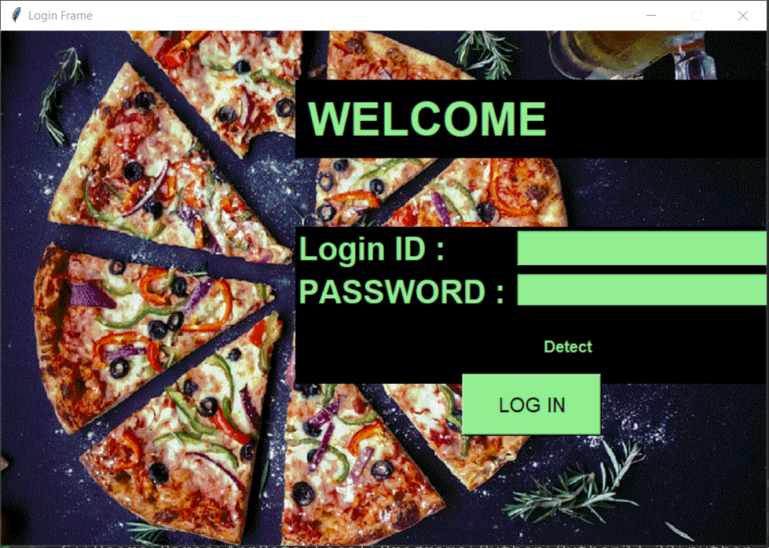
2. **To access the program user should be authenticated by just putting correct login id and password.** 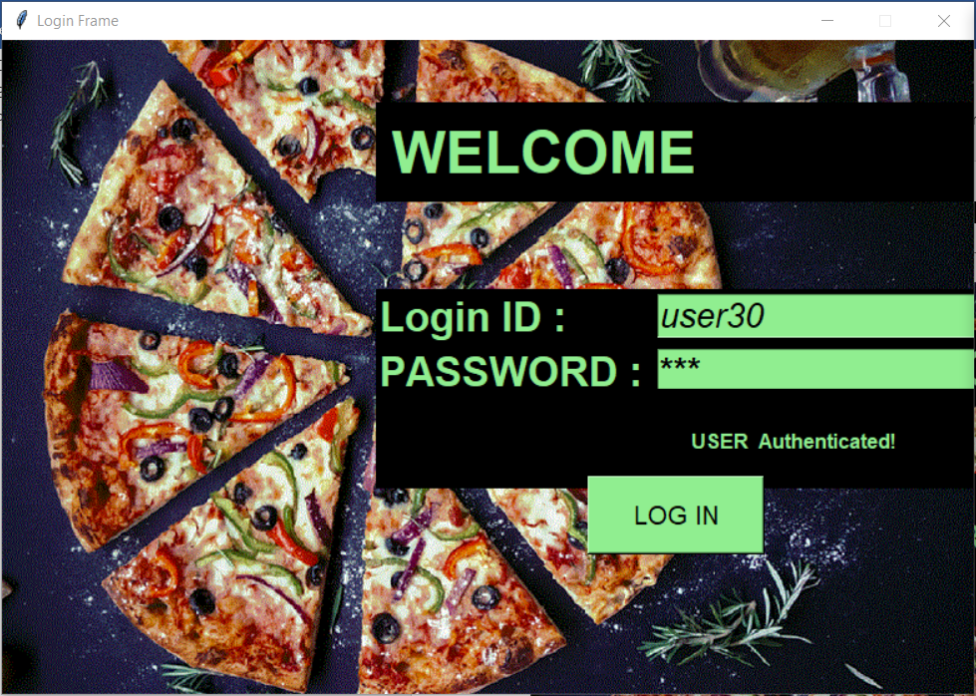
3. **In our project we had provided a simple and easy frameware for user who are using this project.** 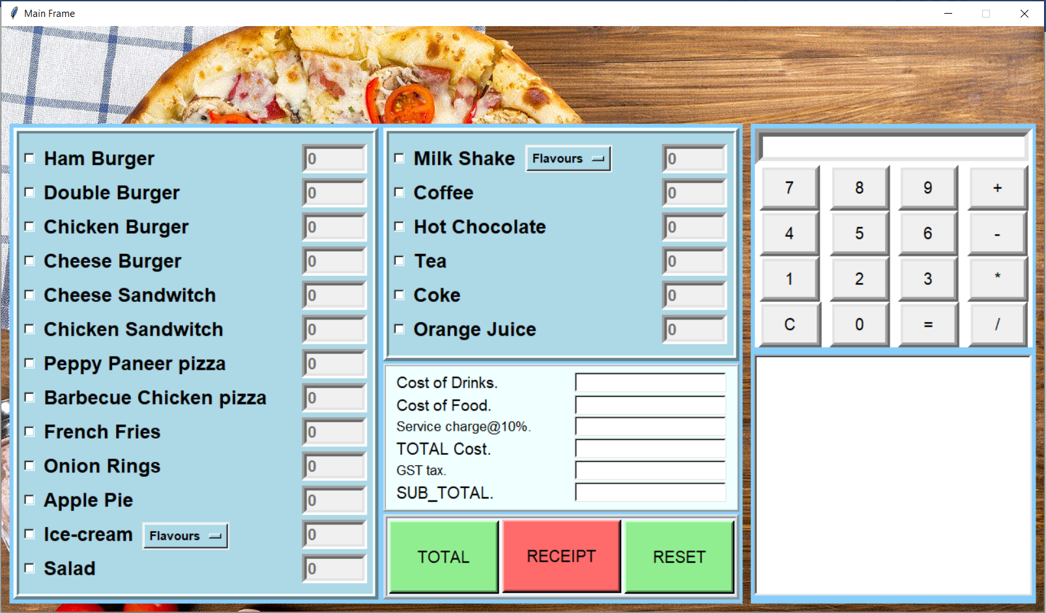
4. 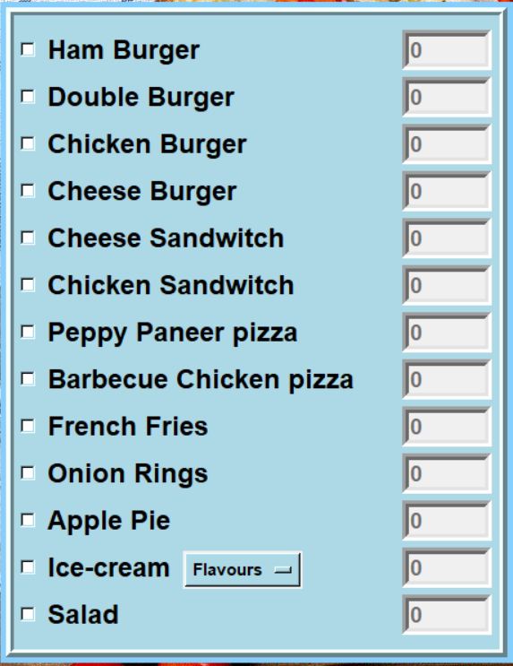**At first we got food menu from which customer can decide to which food is need to be selected and user is just need to click that particular item that customer needs with its quantity.**
5. **Then we got drinks menu from which customer can decide to which drinks is need to be selected and user is just need to click that particular drink that customer needs with its quantity.**

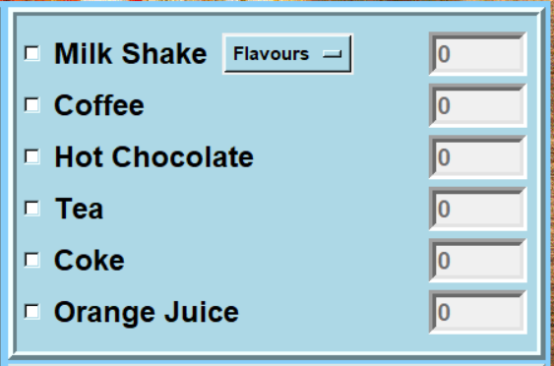

1. **In this accounts section user got a guide on how much cost that customer will pay for drinks and food or an how much service charge and tax customer need to pay for a particular item.**

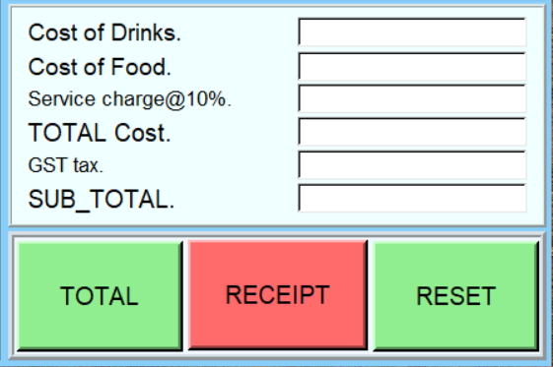

1. **In this user got a receipt of food or drinks and its subtotal for customers guide.**

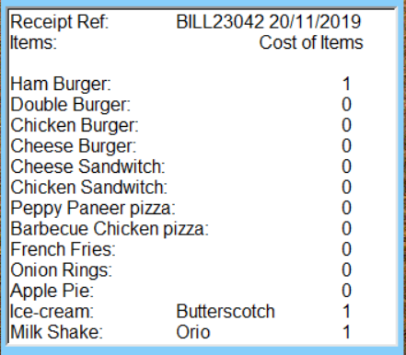

1. **At last we had provided a calculator for needs of user.**

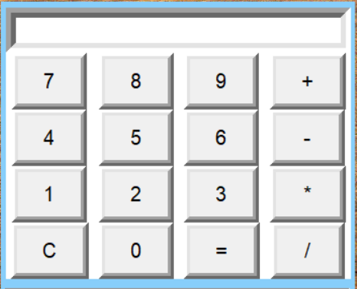

**CHAPTER 4**

**REQUIREMENTS**

**4.1 HARDWARE REQUIREMENTS**

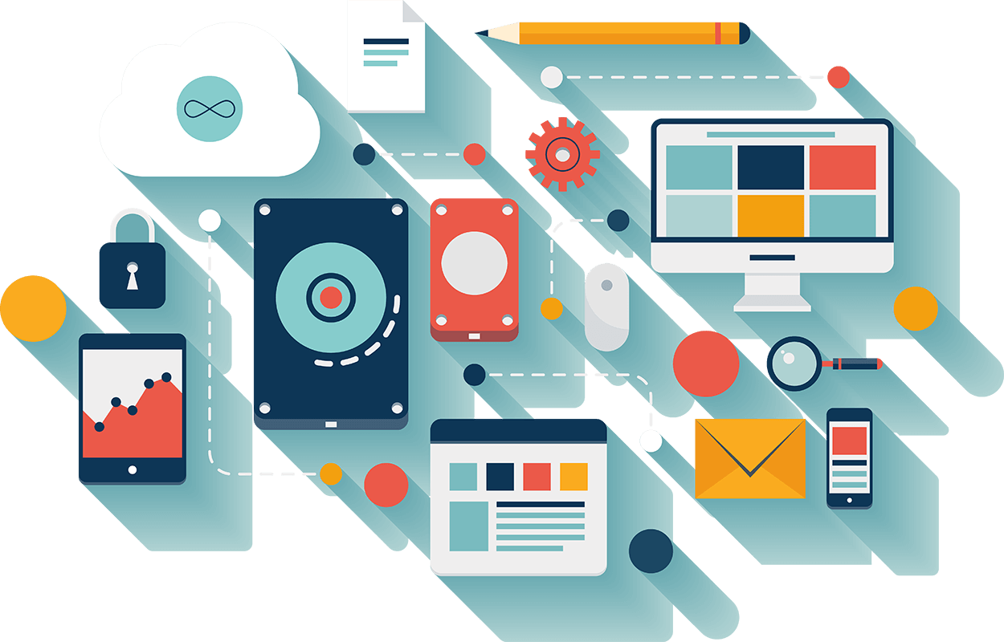

Computer hardware includes the physical parts or components of a computer, such as the central processing unit, monitor, keyboard, computer data storage, graphic card, sound card, speakers and motherboard. By contrast, software is instructions that can be stored and run by hardware.

Hardware is directed by the software to execute any command or instruction. A combination of hardware and software forms a usable computing system.

The software we have created is quite compact in nature and hence does not require much from hardware. Its requirements are low and can easily be fulfilled by today’s computers. Its requirement being as follows: -

* 1 GB RAM
* A Display Screen
* Intel® Core™ i3 processor
* A keyboard and a mouse

This is the minimum requirement for Hardware, to have better performance the requirement can always be matched with higher specs.

Recommend hardware would be: -

* 4 GB RAM
* A Display Screen
* Intel® Core™ i5 processor
* 2 GB Graphics card
* A keyboard and a mouse

Any higher than this is redundant in nature for the software.

**4.2 SOFTWARE REQUIREMENTS**

As we are developing a small software and it has software requirement as follows: -

* **Python**

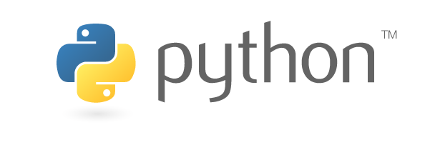

Python can be easy to pick up whether you're a first-time programmer or you're experienced with other languages. The following pages are a useful first step to get on your way writing programs with Python!

Python is developed under an OSI-approved open source license, making it freely usable and distributable, even for commercial use. Python's license is administered by the Python Software Foundation.

The Python Package Index (PyPI) hosts thousands of third-party modules for Python. Both Python's standard library and the community-contributed modules allow for endless possibilities.

The community hosts conferences and meetups, collaborates on code, and much more. Python's documentation will help you along the way, and the mailing lists will keep you in touch.

* **Pycharm IDE**

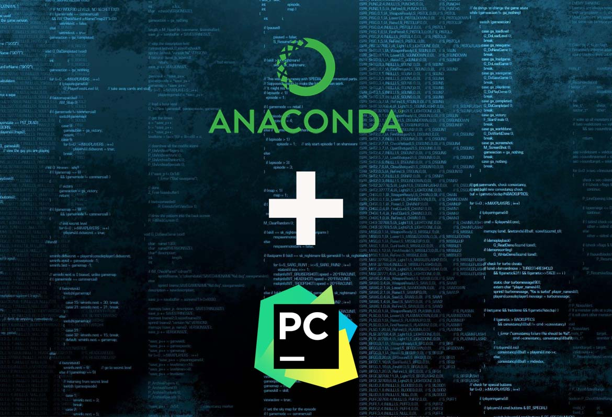

Python **PyCharm** is an integrated development environment (IDE) used in computer programming, specifically for the Python language. It is developed by the Czech company JetBrains.

 It provides code analysis, a graphical debugger, an integrated unit tester, integration with version control systems (VCSes), and supports web development with Django.

PyCharm is cross-platform, with Windows, macOS and Linux versions. The Community Edition is released under the Apache License, and there is also Professional Edition released under a proprietary license - this has extra features

PyCharm knows everything about your code. Rely on it for intelligent code completion, on-the-fly error checking and quick-fixes, easy project navigation, and much more.

* **Libraries**

The libraries are what we use in python as tools. These tools helps us to complete a project or a program with much easy. As these are only tools but not the programs themselves, we have to learn how to use them to actually implement them on our project and also identifying that if they are what we require to get the job done.

The libraries we have used are as follows:-

* **Tkinter**



Tkinter is a Python binding to the Tk GUI toolkit. It is the standard Python interface to the Tk GUI toolkit and is Python's de facto standard GUI. Tkinter is included with standard Linux, Microsoft Windows and Mac OS X installs of Python. The name Tkinter comes from Tk interface. Tkinter was written by Fredrik Lundh. Tkinter is free software released under a Python license. Tkinter uses a Parent-child relation to establish one widget with another. For example: If you place a text label inside a frame, the frame is the parent of the label.

As above mentioned we have used this library to create a GUI for the user to actually be able to see what it is that the program provides and then selects what the user actually wants with it.

* **Socket**

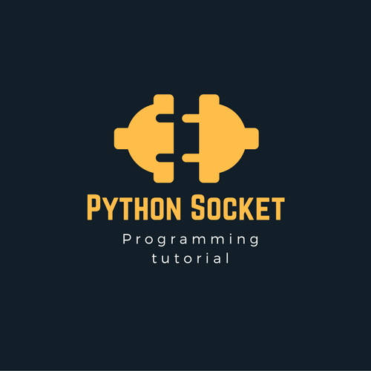

The Python interface is a straightforward transliteration of the Unix system call and library interface for sockets to Python’s object-oriented style: the [socket()](https://docs.python.org/3/library/socket.html#socket.socket) function returns a socket object whose methods implement the various socket system calls. Parameter types are somewhat higher-level than in the C interface: as with read() and write() operations on Python files, buffer allocation on receive operations is automatic, and buffer length is implicit on send operations.

* **SQL**

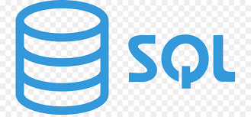

**SQL** is a database computer language designed for the retrieval and management of data in a relational database. **SQL** stands for **Structured Query Language**. This tutorial will give you a quick start to SQL. It covers most of the topics required for a basic understanding of SQL and to get a feel of how it works.

**CHAPTER 6**

**CONCLUSION**

We have created this project using core python3 programing language and used some of the libraries like socket and Tkinter for GUI. This is a simple GUI based application which is very easy to understand and use. It uses [Tkinter](https://wiki.python.org/moin/TkInter) module for the GUI. Talking about the application, the user just has to select among the food and drinks items, enter the quantity and click on the total button to view the total price.

The user can view the total receipt of their items which displays receipt number and number of their food/drinks items with the total amount. There’s also an extra calculator feature for the users. Here, the total bill of the customer includes tax and service charges too. The design is so simple that the user won’t find any difficulties while working on it.

**REFERENCES**

<https://jetbrains.com/pycharm/download/>

IDE for using Python

<http://effbot.org/tkinterbook/>

Used for help in GUI

<https://www.python.org/downloads/>

Used to get latest version of Python